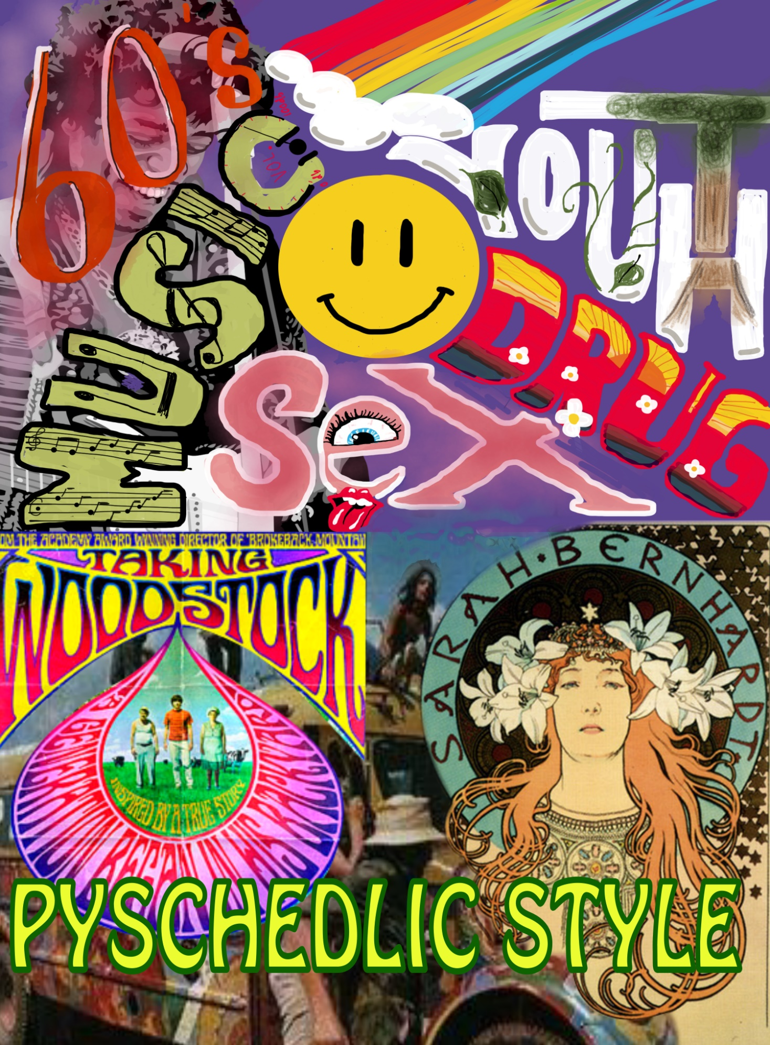

Color Scheme

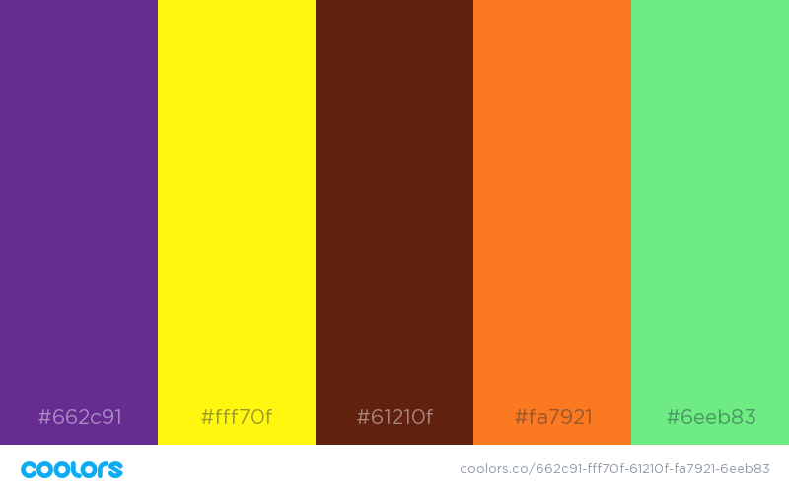

The colors of the psychedelic style are very significant from other styles, as they’re often very vibrant and sharp. The wide range of colors creates a great contrast, which attributes to the “trippy” look. The classic 60’s brown and orange not only characterizes the era, but are also colors inspired by the Art Nouveau, from which the psychedelic artform originates

Psychedelic Style

A Revolutionary Style of The Youth

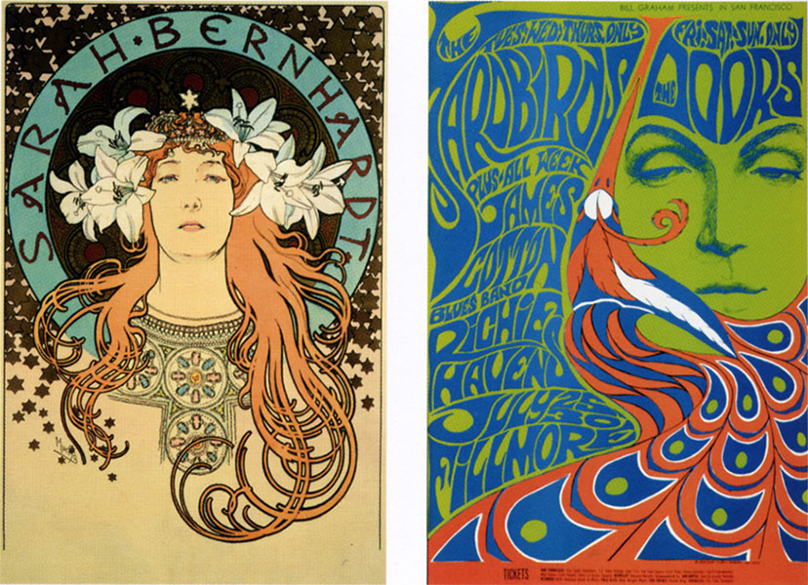The psychedelic style was introduced in the late 60’s, and was used broadly throughout the 70’s as well. The psychedelic style is very unlikely from earlier styles in the 1900’s, making it very untraditional. However, the psychedelic has some origins from the Art Nouveau, characterized by the romantic and very natural way of expression. Featured characteristics often include psychedelic and euphoric elements, as a visualization of the effects of drugs, such as LSD.

Alfons Mucha, 1896; Bonnie Maclean, 1967

Psychedelic drugs were widely used among the so called “baby boomers”, the generation born after World War 2, when the birth rate increased massively. During the 60´s, this generation entered its teenage years, causing a historic youth revolution. A new pacifistic lifestyle, inspired by Buddhism, became the ideology of the Flower Power movement, and gave birth to the classic “hippie”. During that time, it became fashionable to rebel against the usual norms, in every part of society.

The psychedelic style was used visually and audibly in music, art, fashion etc. This led to an era, that has inspired memorable artists such as Jimi Hendrix, Pink Floyd, Janis Joplin, who are still praised today.

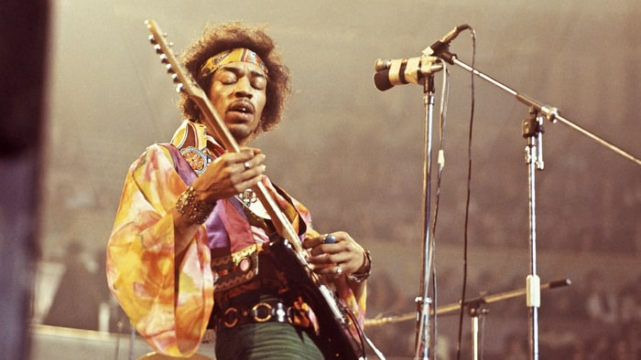

Jimi Hendrix performing in England, 1969

The influence of drugs is clearly shown in the general style of typography and art, during that period. It often features a very abstract look with uneven, wavy lines, a wide color spectrum and abnormal structure of letters and objects. The typeface is often very soft and solid, with large, and grotesque letters in different colors. It resembles the hallucinations one would experience under the influence of recreational drugs. The organic and untraditional typography emphasizes the hippie love for nature and free will.

Logo Development

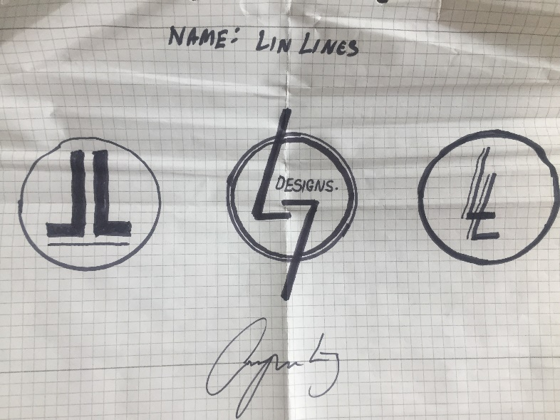

**Initial logo sketching ideas.**

The first piece of inspiration came from my own signature, which intertwines the initials L and J.

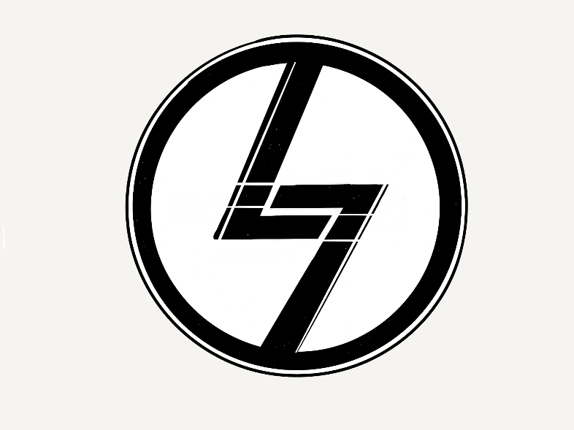

**Detailed digital sketch.**

The logo now also shows two i’s, forming

two mirrored shapes spelling “Li” for “Lin Lines”

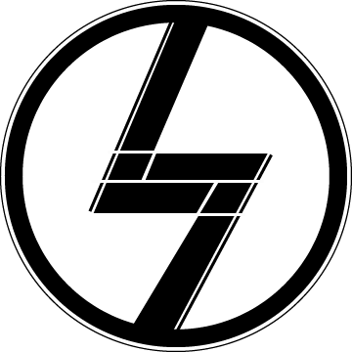

**Final Logo in Illustrator.**

The logo is finalized in Illustrator, with precise and even lines. The background is transparent, and the size and format remains flexible.

Image assets

The same image is resized optimally for each device

**Small (500px width, for smartphones)**

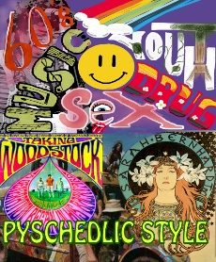

**Medium (1000px, for tablet)**

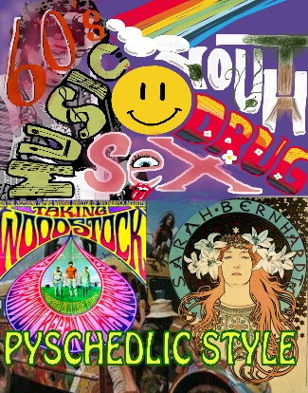

**Large (2000px, for desktop)**

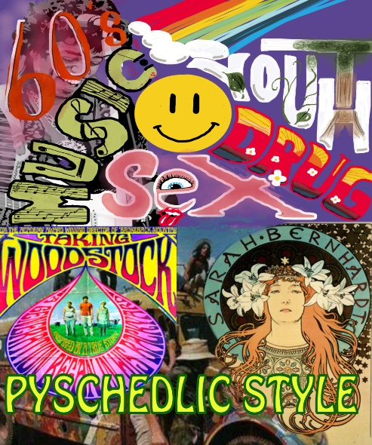

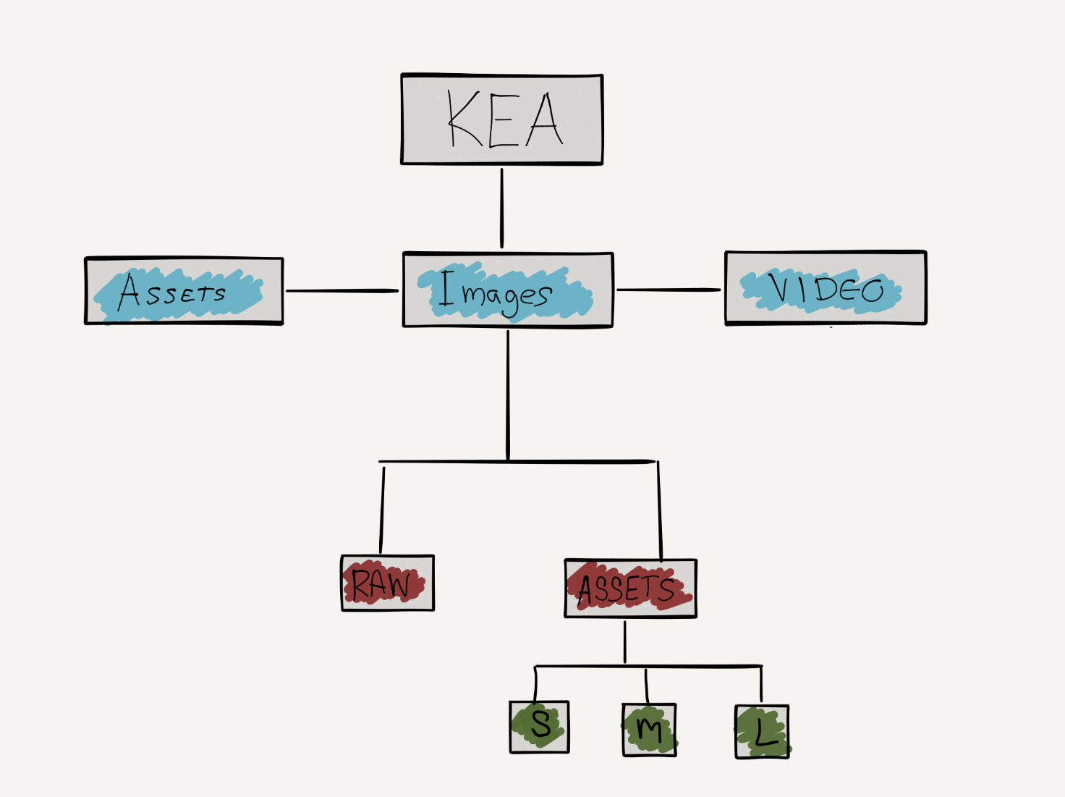Folder Structure

A visualization of the folder structure for the content library.